Неделя 1:

Building a WebPage With HTML

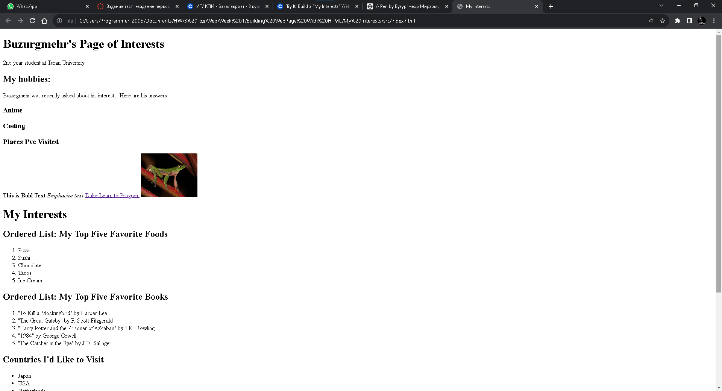

HTML:

<!DOCTYPE html>

<html lang="en" dir="ltr">

<head>

<meta charset="utf-8">

<title>My Interests</title>

</head>

<body>

<div>

<h1>Buzurgmehr's Page of Interests</h1>

<p>2nd year student at Turan University</p>

</div>

<div>

<h2>My hobbies:</h2>

<p>Buzurgmehr was recently asked about his interests. Here are his answers!</p>

<h3>Anime</h3>

<h3>Coding</h3>

<h3>Places I've Visited</h3>

</div>

<b>This is Bold Text</b>

<em>Emphasize text</em>

<a href="http://www.dukelearntoprogram.com/" target="blank_">Duke Learn to Program</a>

<img src="https://upload.wikimedia.org/wikipedia/commons/thumb/0/0c/Golden-eyed_tree_frog_%28Agalychnis_annae%29_1.jpg/500px-Golden-eyed_tree_frog_%28Agalychnis_annae%29_1.jpg" width=150 />

<h1>My Interests</h1>

<h2>Ordered List: My Top Five Favorite Foods</h2>

<ol>

<li>Pizza</li>

<li>Sushi</li>

<li>Chocolate</li>

<li>Tacos</li>

<li>Ice Cream</li>

</ol>

<h2>Ordered List: My Top Five Favorite Books</h2>

<ol>

<li>"To Kill a Mockingbird" by Harper Lee</li>

<li>"The Great Gatsby" by F. Scott Fitzgerald</li>

<li>"Harry Potter and the Prisoner of Azkaban" by J.K. Rowling</li>

<li>"1984" by George Orwell</li>

<li>"The Catcher in the Rye" by J.D. Salinger</li>

</ol>

<h2>Countries I'd Like to Visit</h2>

<ul>

<li>Japan</li>

<li>USA</li>

<li>Netherlands</li>

</ul>

<h2>Dream Jobs</h2>

<ul>

<li>Photographer</li>

<li>Mobile Developer</li>

<li>Frontend Developer</li>

</ul>

<h2>Table</h2>

<table border="1">

<tr>

<th>Event</th>

<th>Date</th>

<th>Location</th>

<th>Description</th>

</tr>

<tr>

<td>Vacation</td>

<td>July 2024</td>

<td>Santorini, Greece</td>

<td>Relax on beautiful beaches and explore Greek culture</td>

</tr>

<tr>

<td>Conference</td>

<td>November 2024</td>

<td>San Francisco, USA</td>

<td>Attend a tech conference on AI and innovation</td>

</tr>

<tr>

<td>Exhibition</td>

<td>March 2025</td>

<td>Paris, France</td>

<td>Visit the Louvre Museum and explore Parisian art</td>

</tr>

<tr>

<td>Expedition</td>

<td>June 2025</td>

<td>Amazon Rainforest</td>

<td>Research and document wildlife in the rainforest</td>

</tr>

</table>

</html>

Styling a WebPage with CSS

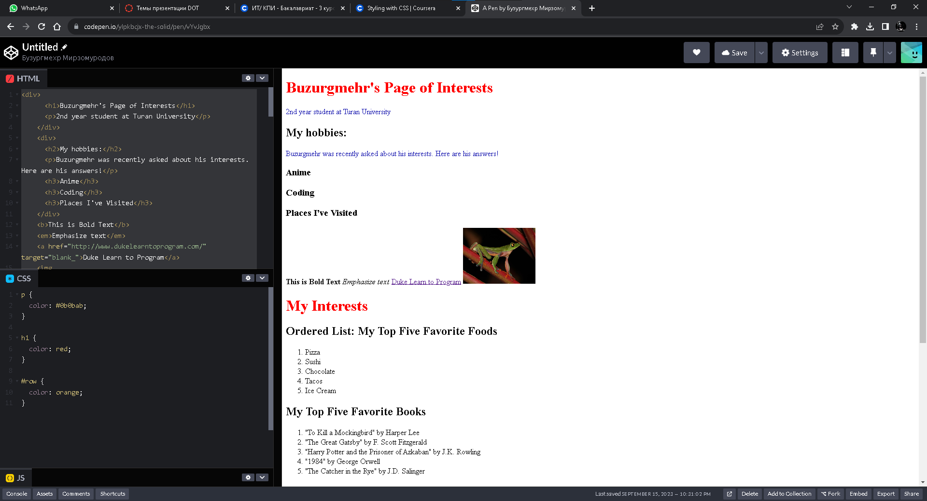

HTML:

<div>

<h1>Buzurgmehr's Page of Interests</h1>

<p>2nd year student at Turan University</p>

</div>

<div>

<h2>My hobbies:</h2>

<p>Buzurgmehr was recently asked about his interests. Here are his answers!</p>

<h3>Anime</h3>

<h3>Coding</h3>

<h3>Places I've Visited</h3>

</div>

<b>This is Bold Text</b>

<em>Emphasize text</em>

<a href="http://www.dukelearntoprogram.com/" target="blank_">Duke Learn to Program</a>

<img src="https://upload.wikimedia.org/wikipedia/commons/thumb/0/0c/Golden-eyed_tree_frog_%28Agalychnis_annae%29_1.jpg/500px-Golden-eyed_tree_frog_%28Agalychnis_annae%29_1.jpg" width=150 />

<h1>My Interests</h1>

<h2>Ordered List: My Top Five Favorite Foods</h2>

<ol>

<li>Pizza</li>

<li>Sushi</li>

<li>Chocolate</li>

<li>Tacos</li>

<li>Ice Cream</li>

</ol>

<h2>My Top Five Favorite Books</h2>

<ol>

<li>"To Kill a Mockingbird" by Harper Lee</li>

<li>"The Great Gatsby" by F. Scott Fitzgerald</li>

<li>"Harry Potter and the Prisoner of Azkaban" by J.K. Rowling</li>

<li>"1984" by George Orwell</li>

<li>"The Catcher in the Rye" by J.D. Salinger</li>

</ol>

<h2>Countries I'd Like to Visit</h2>

<ul>

<li>Japan</li>

<li>USA</li>

<li>Netherlands</li>

</ul>

<h2>Dream Jobs</h2>

<ul>

<li>Photographer</li>

<li>Mobile Developer</li>

<li>Frontend Developer</li>

</ul>

<h2>Table</h2>

<table border="1">

<tr id="row">

<th>Event</th>

<th>Date</th>

<th>Location</th>

<th>Description</th>

</tr>

<tr>

<td>Vacation</td>

<td>July 2024</td>

<td>Santorini, Greece</td>

<td>Relax on beautiful beaches and explore Greek culture</td>

</tr>

<tr>

<td>Conference</td>

<td>November 2024</td>

<td>San Francisco, USA</td>

<td>Attend a tech conference on AI and innovation</td>

</tr>

<tr>

<td>Exhibition</td>

<td>March 2025</td>

<td>Paris, France</td>

<td>Visit the Louvre Museum and explore Parisian art</td>

</tr>

<tr>

<td>Expedition</td>

<td>June 2025</td>

<td>Amazon Rainforest</td>

<td>Research and document wildlife in the rainforest</td>

</tr>

</table>

CSS:

p {

color: #0b0bab;

}

h1 {

color: red;

}

#row {

color: orange;

}

Тесты:

Practice Quiz: Using HTML – Formatting Text

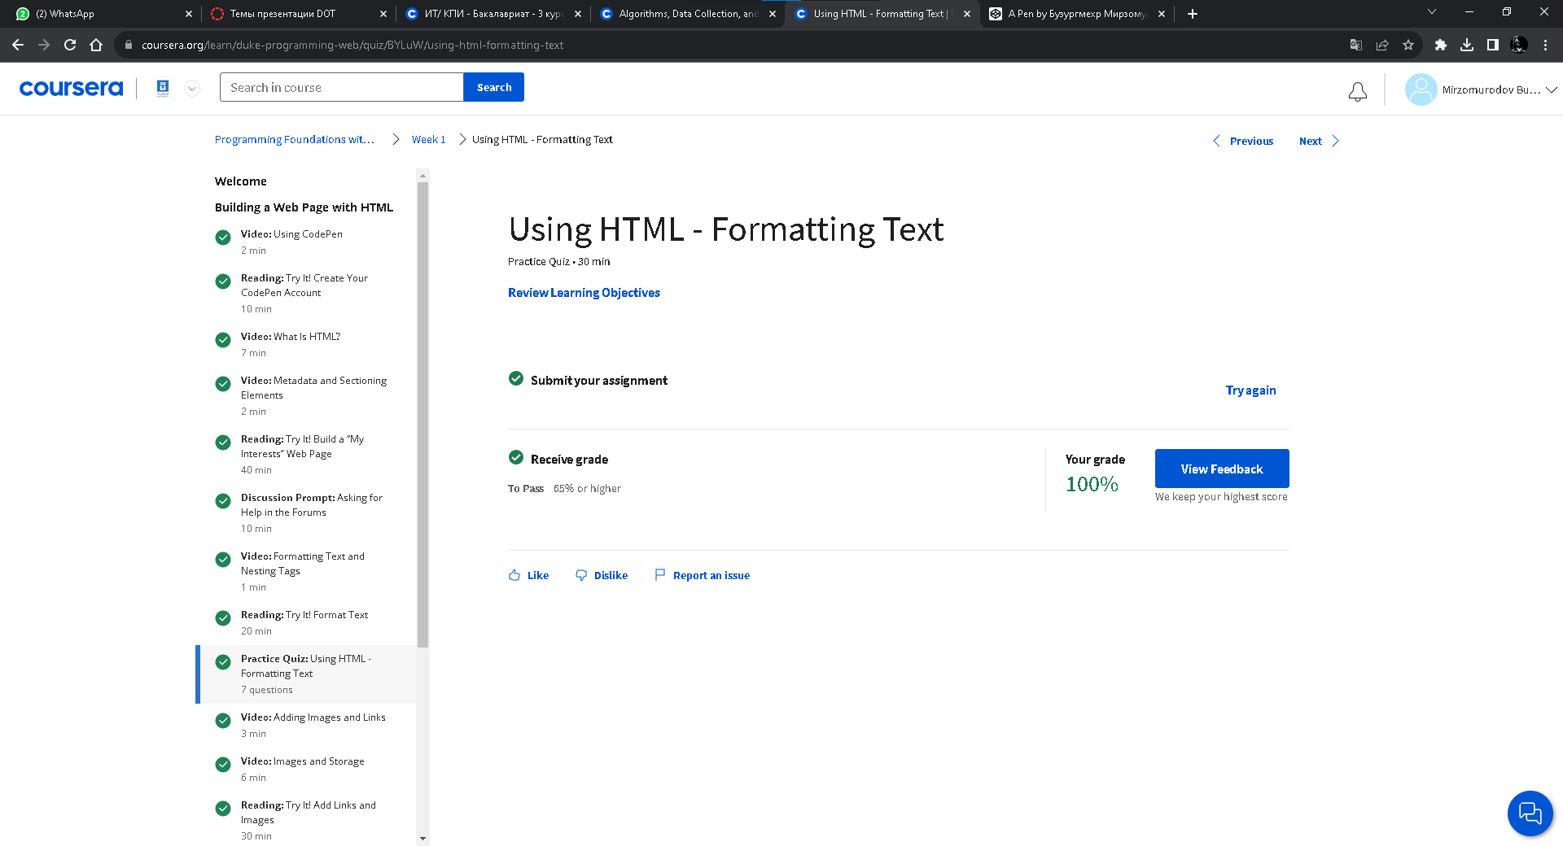

Practice Quiz: Using HTML – Displaying Data

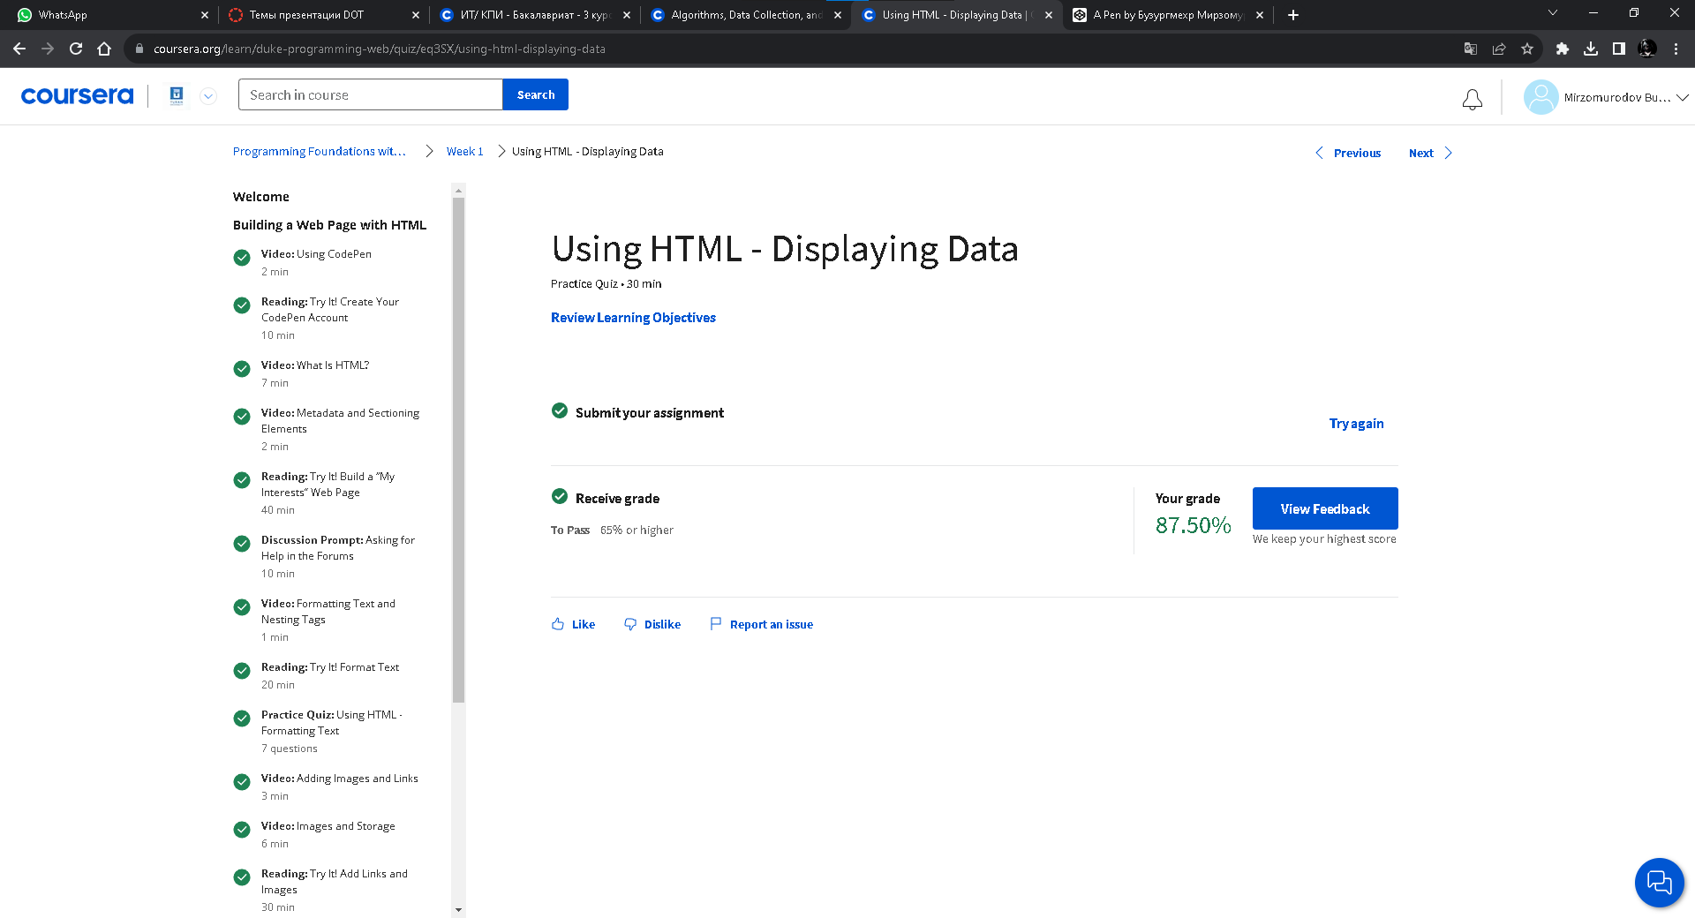

Practice Quiz: Styling With CSS

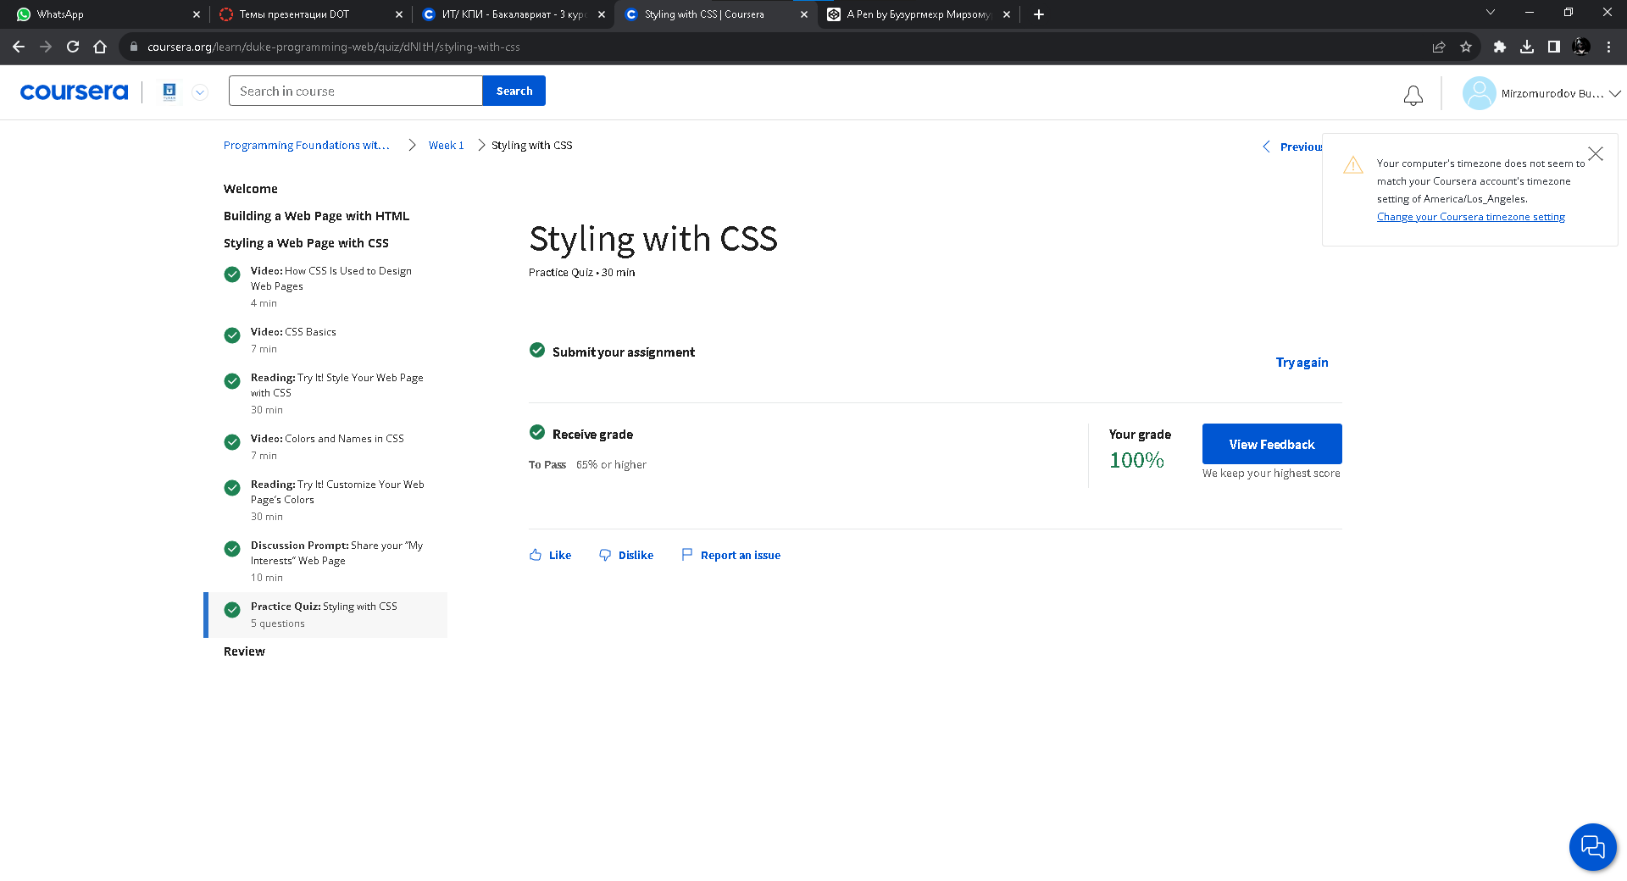

Quiz: Designing a Web Page with HTML and CSS

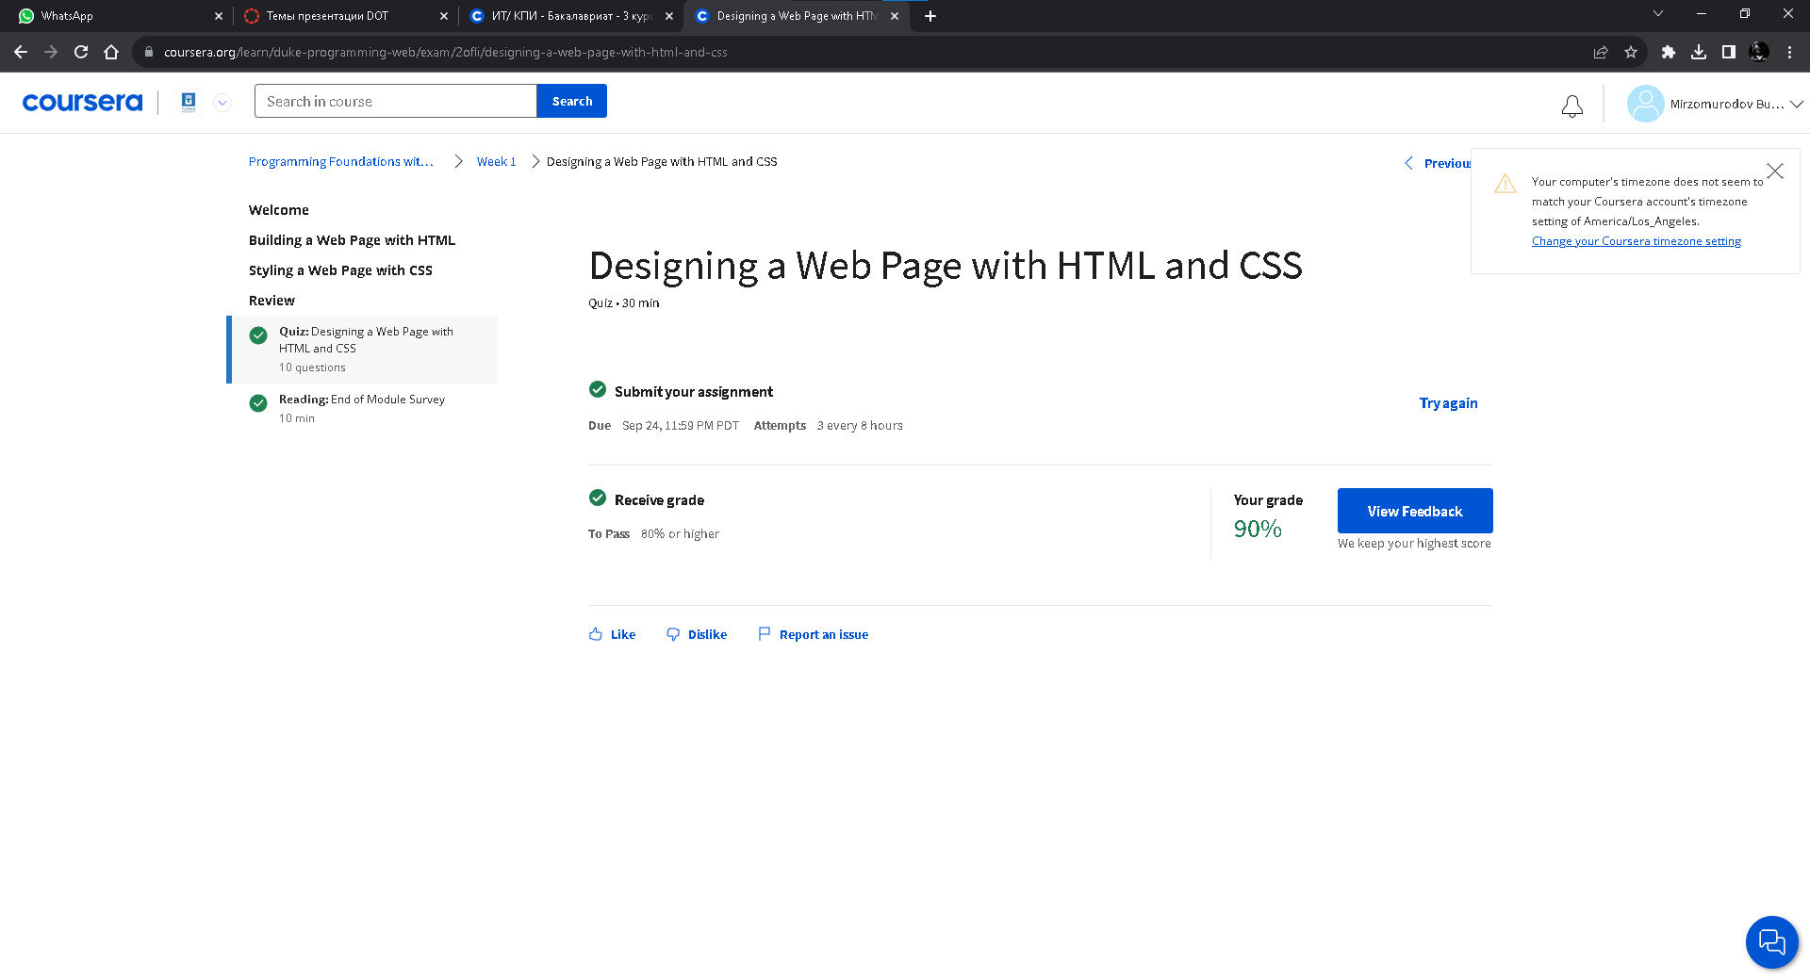

Week 1: Completed!

